

AIR QUALITY INTELLIGENCE
India Air Pollution Monitoring, Operational and Risk Analysis
FINAL PROJECT REPORT

AI Specialist — Data Analyst Track
Prepared by: Rapaka Baby Varalakshmi
Date: 21 September 2026

Table of Contents
1. Introduction 3
2. Project Initialization and Planning Phase 3
3. Data Collection and Preprocessing Phase 4
4. Data Visualization 4
5. Dashboard 8
6. Report 8
7. Performance Testing 9
8. Conclusion/Observation 10
9. Future Scope 10
10. Appendix 10

Introduction

1.1. Project Overview
India's air pollution monitoring infrastructure generates large volumes of station-level pollutant and meteorological data, but converting this raw data into actionable intelligence for analysts, policymakers, and health researchers is a significant challenge. This project — Air Quality Intelligence: India Air Pollution Monitoring, Operational and Risk Analysis — builds an end-to-end SQL + Power BI solution covering 10,521 station-level readings across 503 monitoring stations, 268 cities, and 30 Indian states, delivering 5 report pages, 7 custom DAX measures, an AI-powered Decomposition Tree, Key Influencers analysis, and 30+ visuals in total.

1.2. Objectives
- Identify the highest-AQI cities and stations, and the pollutants driving them.
- Track AQI_Bucket distribution (Good to Hazardous) for compliance monitoring across states and seasons.
- Correlate pollutant concentrations with meteorological conditions (temperature, humidity, wind speed).
- Serve three stakeholder personas: a Data Analyst, an Urban Policy & Compliance Officer, and a Public Health Researcher.

Project Initialization and Planning Phase

2.1. Define Problem Statement
PS | I am (Customer) | I'm trying to | But | Because | Which makes me feel
PS-1 | a Data Analyst at a state pollution-control unit | identify the highest-AQI cities and stations | station data is scattered with no easy way to compare or drill in | monitoring teams need to know where to act first | overwhelmed by data volume with no clear priorities
PS-2 | an Urban Policy & Compliance Officer | track AQI_Bucket compliance and issue timely advisories | data isn't organized by threshold, season, or state | I need to time restrictions before pollution peaks | reactive instead of proactive on public health
PS-3 | a Public Health Researcher | link pollutant exposure to population health risk | pollutant and weather data aren't correlated anywhere | I need solid evidence behind health advisories | uncertain my guidance is fully data-backed

2.2. Project Proposal (Proposed Solution)
Objective: Build a SQL + Power BI intelligence dashboard that converts raw, station-level air quality and meteorological data into actionable insight for data analysts, policy/compliance officers, and public health researchers across India.
Scope: 10,521 station-level readings across 503 monitoring stations, 268 cities, and 30 states, including 7 pollutants (PM2.5, PM10, NO2, SO2, CO, OZONE, NH3), AQI/AQI_Bucket classification, and meteorological data over multiple years and seasons.
Approach: Data was loaded into a MySQL database (validated via SQL: row counts, null checks, min/max AQI, grouped averages), then connected to Power BI Desktop. DAX measures, a Decomposition Tree, and a Key Influencers visual surfaced the key drivers of AQI severity across 5 report pages and 30+ visuals.
Key Features: End-to-end SQL-to-Power BI pipeline; 7 DAX measures; AI-assisted insights via Decomposition Tree and Key Influencers; a natural-language Q&A visual; interactive slicers; and two role-specific reports addressing all three stakeholder personas.

2.3. Initial Project Planning
Sprint | Functional Requirement | User Story / Task | Story Pts
Sprint-1 | Problem Definition & Data Collection | Identify business problem; define objectives across 3 personas; collect and understand enriched_aqi.csv. | 5
Sprint-1 | Database Setup & SQL Analysis | Create MySQL database, import data, write validation and exploratory SQL queries. | 6
Sprint-2 | Power BI Data Prep & AI Insights | Connect Power BI to MySQL; build DAX measures, Decomposition Tree, Key Influencers. | 8
Sprint-3 | Data Visualization & Dashboard | Build 30+ visuals across dashboard pages; add Q&A visual and slicers. | 10
Sprint-3 | Report Development | Consolidate visuals into two role-specific reports. | 5
Sprint-4 | Performance Testing & Documentation | Document data load, filters, measures, visuals; record demo; write final report. | 5

Data Collection and Preprocessing Phase

3.1. Data Collection Plan and Raw Data Sources Identified
Source Name | Description | Format | Size | Access
enriched_aqi.csv | Enriched Indian air quality dataset: pollutant concentrations, AQI/AQI_Bucket, station geolocation, and meteorological readings. | CSV | 10,521 rows x 22 cols | Project dataset

3.2. Data Quality Report
Data Source | Issue | Severity | Resolution
enriched_aqi.csv | 357 of 10,521 rows (~3.4%) missing pollutant_min/max/avg. | Low | Excluded from pollutant-specific averages only; AQI itself never null.
enriched_aqi.csv | last_update stored as text, not date/time. | Low | Converted to Date/Time in Power Query for date hierarchy.
enriched_aqi.csv | Checked for duplicate rows. | None found | No action needed — 0 duplicates confirmed via SQL.

3.3. Data Exploration and Preprocessing
- Explored via SQL: row counts, null checks, min/max AQI, average AQI by city/season, pollutant-wise averages, top hazardous readings.
- Power Query: filtered null pollutant_avg rows for pollutant-specific visuals; created Year/Month/Season calculated columns; converted last_update to Date/Time.
- Data types confirmed: AQI, pollutant fields, lat/long, and weather fields as numeric; city, state, station, pollutant_id, AQI_Bucket, Season as text.
- Single fact table (enriched_aqi) used in Power BI with 7 DAX measures defined directly on it.
- Cleaned dataset loaded into MySQL (air_quality_db.enriched_aqi) and connected live to Power BI Desktop.

Data Visualization

Framing Business Questions

- Which cities have the highest average AQI?
- How does AQI trend over time?
- What is the geographic distribution of pollution across India?
- What share of readings fall into each AQI compliance category?
- Which pollutants contribute most to overall AQI?
- How does AQI vary by season?
- Is there a relationship between temperature and AQI?
- Is there a relationship between wind speed and AQI?
- What factors most influence high AQI? (AI-assisted insight)

4.2. Developing Visualizations
1. Which cities have the highest average AQI?
Visualization: Horizontal bar chart — Average AQI by city.
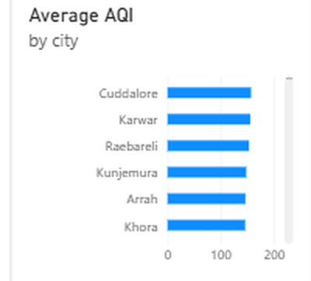
2. How does AQI trend over time?
Visualization: Line chart — Average AQI by date/month.
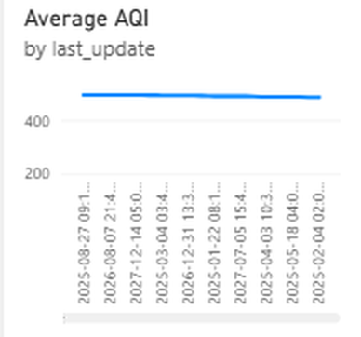
3. What is the geographic distribution of pollution across India?
Visualization: Map — AQI by city (latitude/longitude).
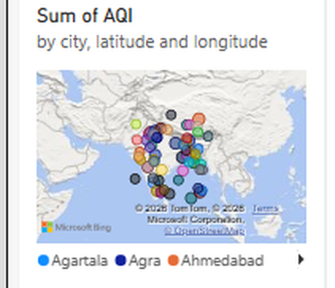
4. What share of readings fall into each AQI compliance category?
Visualization: Donut chart — Total Records by AQI_Bucket.
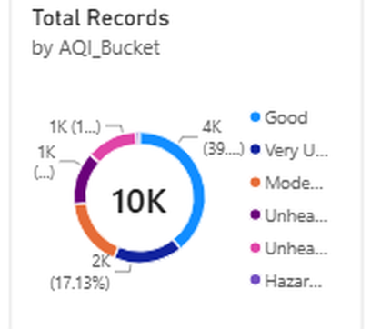
5. Which pollutants contribute most to overall AQI?
Visualization: Pie chart — Average pollutant concentration by pollutant_id.
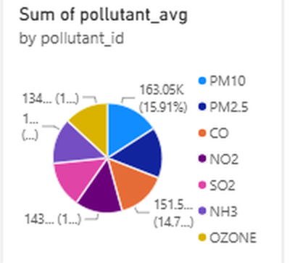

6. How does AQI vary by season?
Visualization: Column chart — Average AQI by Season.
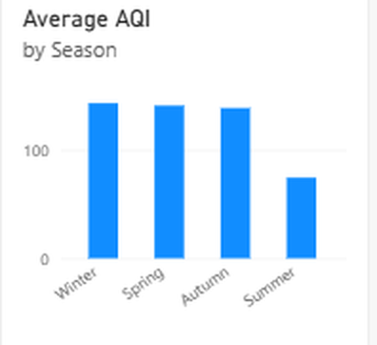
7. Is there a relationship between temperature and AQI?
Visualization: Scatter chart — Temperature (°C) vs AQI by city.
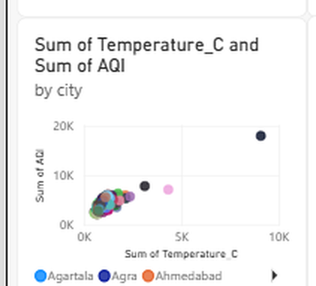
8. Is there a relationship between wind speed and AQI?
Visualization: Scatter chart — Wind Speed (km/h) vs AQI.
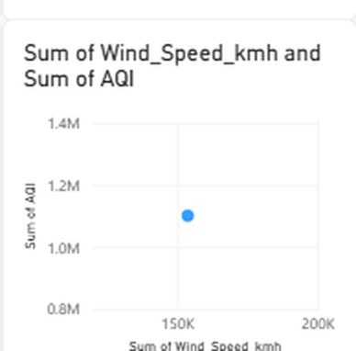

9. What factors most influence high AQI? (AI-assisted insight)
Visualization: Power BI Key Influencers visual.
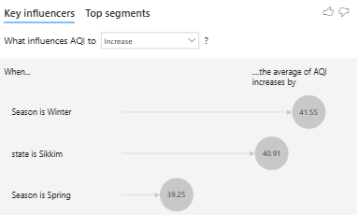

Dashboard

Dashboard Design Screenshot with Insights
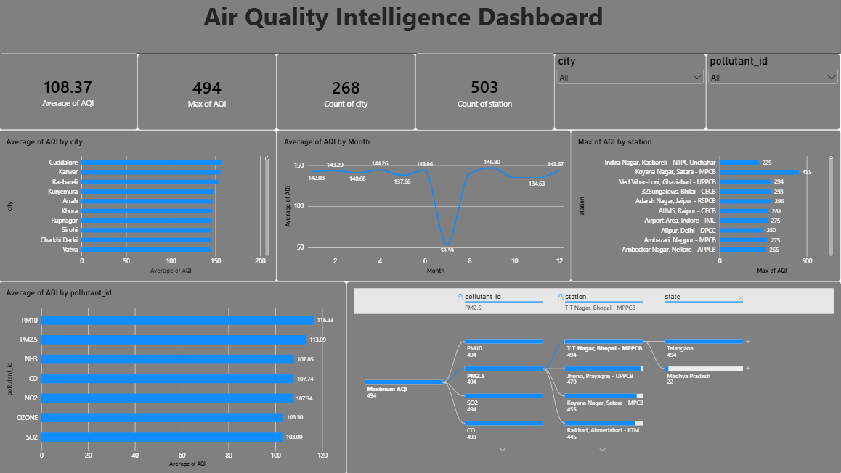

Air Quality Intelligence Dashboard
Overall Air Quality Status: Average AQI of 108.37 across all readings ("Unhealthy for Sensitive Groups"), with a maximum recorded AQI of 494, close to the Hazardous ceiling.
Monitoring Coverage: 268 cities and 503 monitoring stations tracked, confirming broad, high-resolution national coverage.
City-Level Hotspots: Cuddalore, Karwar, and Raebareli top the Average AQI by city chart — mid-sized/industrial cities, not major metros.
Seasonal/Monthly Anomaly: Average AQI by Month shows a sharp, isolated dip around month 7 (53.59) against an otherwise consistent 134–147 range.
Pollutant & Drill-Down Insight: PM10 (116.33) and PM2.5 (113.09) are the highest-averaging pollutants; the Decomposition Tree traces the overall Maximum AQI (494) down to T T Nagar, Bhopal.

6.Report

6.1. Report Design Screenshot with Insights
Report 1 — Air Pollution Monitoring & Analysis Report
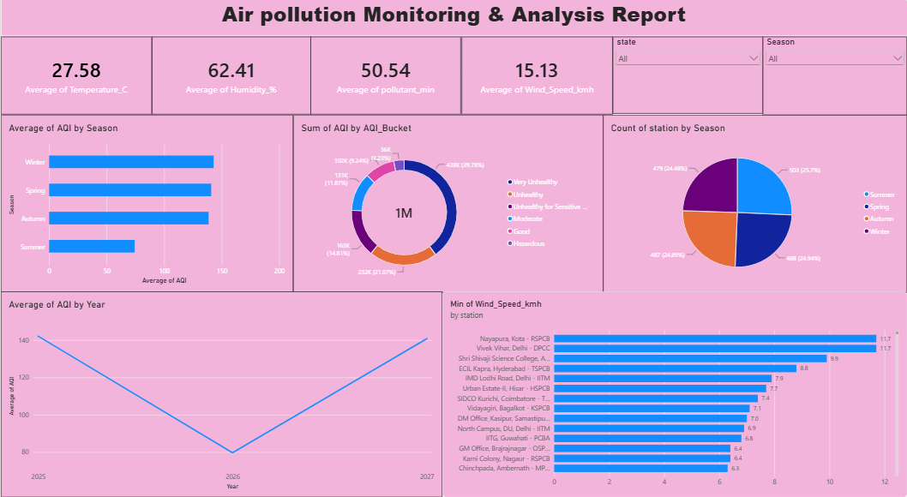
Air Pollution Monitoring & Analysis Report
Average AQI by Year dips sharply in 2026 versus 2025 and 2027. The AQI_Bucket donut shows ~34% of readings fall across Unhealthy-to-Hazardous categories. Station coverage is balanced across all four seasons (479–503), and low-wind stations (as low as 6.3 km/h) are flagged as dispersion-risk candidates.

Report 2 — Air Quality Patterns & Risk Analysis Report
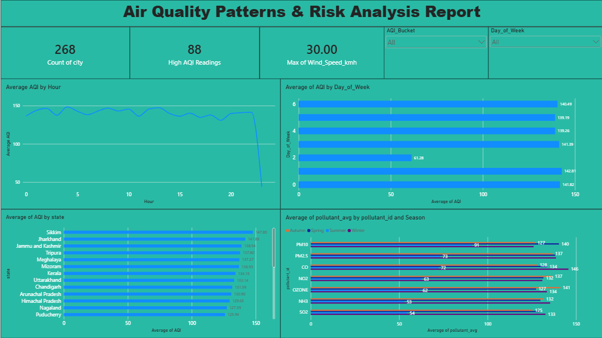
Air Quality Patterns & Risk Analysis Report
Average AQI by Hour stays stable (~130–150) before dropping sharply after Hour 20. One weekday is a clear anomaly (61.28 vs ~139–143). Sikkim again tops the state ranking (147.80), and the High AQI Readings KPI tracks 88 high-risk readings, filterable live by AQI_Bucket and Day_of_Week.

7.Performance Testing

7.1. Utilization of Data Filters
Top N filters (e.g. top 10 cities), and multiple interactive slicers across pages: city, pollutant_id, state, Season, AQI_Bucket, and Day_of_Week — enabling live cross-filtering of every visual on a page.

7.2. No. of Calculation Columns/Measures
7 DAX measures: Total Records, States Covered, Cities Monitored, Monitoring Stations, Average AQI, Maximum AQI, High AQI Readings.

7.3. No. of Visualizations
30+ visuals across 5 report pages, including KPI cards, a Decomposition Tree, a Key Influencers visual, a Q&A visual, maps, trend lines, bar/column charts, donut/pie charts, and scatter charts.

8. Conclusion/Observation

- Pollution severity in India is highly localized — a small number of stations and cities (e.g. T T Nagar, Bhopal; Purnia, Sikkim) drive extreme hazardous readings.
- Season is the single strongest driver of AQI severity, with Winter and Spring both substantially increasing average AQI.
- Particulate matter (PM10, PM2.5) consistently dominates over gas-phase pollutants (SO2, OZONE).
- These findings support prioritized, seasonally-timed interventions and targeted monitoring resource allocation for analysts, compliance officers, and health researchers.

9. Future Scope

- Integrate a live weather/pollution API for real-time (rather than static) data refresh.
- Add a forecasting model (e.g. time-series AQI prediction) to move from descriptive to predictive analytics.
- Publish the report to Power BI Service with scheduled refresh and mobile alerts for Hazardous readings.
- Expand geographic granularity with ward-level or sensor-level data in major metros.
- Automate health-advisory generation by linking AQI_Bucket thresholds to notification workflows.

10. Appendix

10.1. Source Code (SQL Queries)
create database air_quality_db;
use air_quality_db;
SELECT COUNT(*) FROM enriched_aqi;

-- null
SELECT * FROM enriched_aqi
WHERE pollutant_avg IS NULL OR AQI IS NULL;

-- min max
SELECT
MAX(AQI) AS max_aqi,
MIN(AQI) AS min_aqi
FROM enriched_aqi;

-- avg
SELECT city,
ROUND(AVG(aqi),2) AS avg_aqi
FROM enriched_aqi
GROUP BY city
ORDER BY avg_aqi DESC;

-- group by
SELECT Season, AVG(AQI)
FROM enriched_aqi
GROUP BY Season;

SELECT pollutant_id,AVG(pollutant_avg), MAX(pollutant_max)
FROM enriched_aqi
GROUP BY pollutant_id
ORDER BY AVG(pollutant_avg) DESC;

SELECT city, station, AVG(AQI) AS avg_aqi
FROM enriched_aqi
GROUP BY city, station
ORDER BY avg_aqi DESC
LIMIT 5;

USE air_quality_db;
SELECT city, state, station, AQI, AQI_Bucket
FROM enriched_aqi
WHERE AQI_Bucket IN ('Severe', 'Hazardous')
ORDER BY AQI DESC
LIMIT 20

10.2. GitHub & Project Demo Link

GitHub Repository: varamrapaka0005-cpu/Air-Quality-Intelligence-India-Air-Pollution-Monitoring-Operational-and-Risk-Analysis
Project Demo Video: https://github.com/varamrapaka0005-cpu/Air-Quality-Intelligence-India-Air-Pollution-Monitoring-Operational-and-Risk-Analysis/blob/main/demo_video_AQI.mp4

